*Click on the image or title to download BIM object…

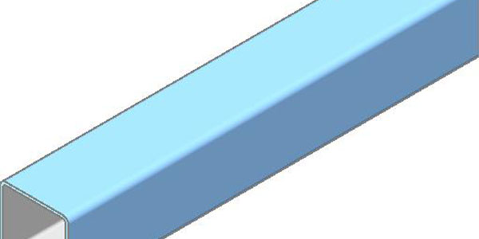

Fireproofing: HSS-Beam
Download Revit Family Files: 2019 2018 2017 2016
type catalog - right click and save to same location as RFA
or, download: DWG

